

Grantee Branding Guidelines and Tools

Contents
Funding Acknowledgement Requirements for Grantees
I. Overview of Acknowledgement Requirements
II. Name Use
III. Social Media Attribution
IV. Impact Sharing
Branding Tools
I. Description of DEC
II. Logo
III. Branded Marketing Templates
IV. Questions & Communications Support

Funding Acknowledgement Requirements for Grantees

Overview of Acknowledgement Requirements
The San Francisco Department of Early Childhood (DEC) must be acknowledged in all external communications efforts related to the services and activities funded by DEC. The following forms of acknowledgment are acceptable:
  - Including statement of funding on digital or printed materials:
“Funding [for this project/program/event] provided [or provided in part] by the San Francisco Department of Early Childhood.”
  - Including DEC’s logo on digital or printed materials.
  - Including verbal acknowledgment in spoken remarks indicating that the project/program/event was made possible with support from DEC.
The DEC team will provide ongoing support and guidance in fulfilling this requirement. Grantees may be asked to furnish copies of relevant promotional and/or marketing materials for review before being released to the public. Where instances of promotion for both DEC and the grantee are available, collateral material may be provided for use by DEC.

Name Use
San Francisco Department of Early Childhood: Use the department’s full name, “San Francisco Department of Early Childhood” on first reference. In running text, using “DEC” on subsequent references is acceptable.
Early Learning For All: Use the full name of our early learning initiative, Early Learning For All, in all instances, and capitalize the first letter of each word in the name.
Family Resource Center Initiative: Please use this when referring to the overall initiative/network. Please write it out fully. Family Resource Centers refer to the funded programs. It is preferred to write this out, but abbreviating to “FRC” is acceptable in text where the term is frequently used.

Social Media Attribution
Tag the San Francisco Department of Early Childhood in social media posts when acknowledging support or promoting the success of your program or event.
  - Social Tags:
Facebook: @sfdepartmentofearlychildhood
X: @sanfranciscoDEC
Instagram: @sanfranciscodec
LinkedIn: @sf-dec

Impact Sharing
As part of your grant funding, we request one of the following every quarter for use on DEC social media
  - 1-2 photos taken during an event or activity, along with a short descriptive caption and signed photo release forms for individuals pictured.
  - 1-2 quotes from individuals served by your organization that speak to the benefit of services provided by your organization. Include quoted individuals’ first names.

Branding Tools

Description of DEC
In press releases pertaining to the funded project/program/event, include the following descriptive paragraph:
About the San Francisco Department of Early Childhood: The Department of Early Childhood (DEC) is a City and County of San Francisco Department dedicated to young children's safe and healthy development. As the City’s largest funder of early childhood, DEC is committed to creating a system that ensures every child can thrive and learn. DEC provides public investment, expertise, and leadership to put resources into the hands of those who care for our City’s youngest children. For more information visit sf.gov/sfdec.

Logo
All printed and digital materials advertising services provided by your organization must bear DEC’s logo, and adhere to the following guidelines:
  - The logo must be used in its entirety and not cropped.
  - On digital media, the logo shall be no smaller than 250 px wide.
  - On printed materials at least 8.5” x 11” (a standard page size), the logo shall be no smaller than 3 in. wide.
    - On printed materials smaller than this, the logo shall be no smaller than 1.75 in. wide.
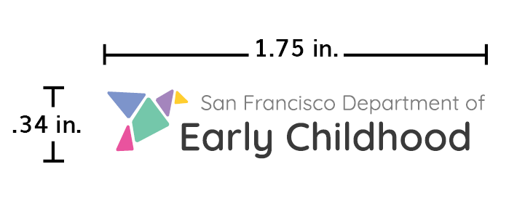
  - The logo should never be distorted in any way or non-uniformly scaled.
  - The logo may be used in one-color dark, one-color white, or in full color.
  - On printed grayscale materials the logo must be used in either one-color dark or one-color white to ensure legibility.
  - The logo should only be used on white or solid colored backgrounds that provide adequate contrast and legibility.
Download logo: Color | One-color dark | One-color white

Branded Event Marketing Templates
When advertising an event or service funded in part by DEC, you are welcomed, but not required to utilize the following Canva templates to develop marketing materials. There are options for events with single and multiple funders:
  - Event Flyers
    - Template 1
    - Template 2
    - Template 3
  - Social Media Graphic Templates
    - Facebook
    - Instagram

  - Postcard
    - Template
Please follow the Acknowledgement guidance in section 1 of this document on all related event information, including on event information and registration pages, in event marketing emails, and on other event communications.

Questions & Communications Support
Do you have a question about these branding guidelines or need additional support from the DEC team? Please reach out to one of our communications team members listed below:
Jonathan Rubinsky (He/Him/His)
Public Relations Officer
jonathan.rubinsky@sfgov.org
Maya Castleman (she/her/hers)
Community Relations Officer
maya.castleman@sfgov.org

